Free Morpheme

🟢 What is a Free Morpheme?
# Source: AI Source: Provided by: [Data Path: Persons Table -> ID Column: 1, Name_En Column: Motasem Essam] -> From: [Chatgpt (GPT-4-turbo)] on [7/24/2025]
A free morpheme is the smallest unit of meaning that can stand alone as a complete word in a sentence.

📘 Definition:
# Source: AI Source: Provided by: [Data Path: Persons Table -> ID Column: 1, Name_En Column: Motasem Essam] -> From: [Chatgpt (GPT-4-turbo)] on [7/24/2025]
A free morpheme is a morpheme that does not need to be attached to another morpheme to express meaning.

✅ Key Features:
# Source: AI Source: Provided by: [Data Path: Persons Table -> ID Column: 1, Name_En Column: Motasem Essam] -> From: [Chatgpt (GPT-4-turbo)] on [7/24/2025]
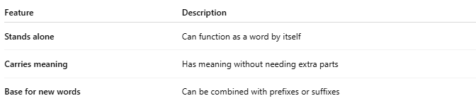
Feature | Description
Stands alone | Can function as a word by itself
Carries meaning | Has meaning without needing extra parts
Base for new words | Can be combined with prefixes or suffixes

🧾 Examples of Free Morphemes:
# Source: AI Source: Provided by: [Data Path: Persons Table -> ID Column: 1, Name_En Column: Motasem Essam] -> From: [Chatgpt (GPT-4-turbo)] on [7/24/2025]
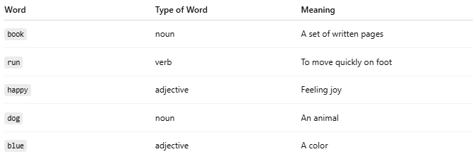
Word | Type of Word | Meaning
book | noun | A set of written pages
run | verb | To move quickly on foot
happy | adjective | Feeling joy
dog | noun | An animal
blue | adjective | A color

🔄 Free Morphemes vs. Bound Morphemes:
# Source: AI Source: Provided by: [Data Path: Persons Table -> ID Column: 1, Name_En Column: Motasem Essam] -> From: [Chatgpt (GPT-4-turbo)] on [7/24/2025]
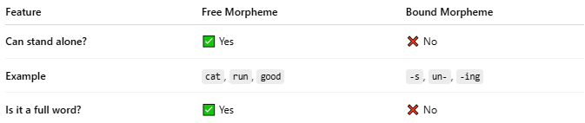
Feature | Free Morpheme | Bound Morpheme
Can stand alone? | ✅ Yes | ❌ No
Example | cat, run, good | -s, un-, -ing
Is it a full word? | ✅ Yes | ❌ No

🧠 Example in a Sentence:
# Source: AI Source: Provided by: [Data Path: Persons Table -> ID Column: 1, Name_En Column: Motasem Essam] -> From: [Chatgpt (GPT-4-turbo)] on [7/24/2025]
"Dogs bark loudly."
- Dog = free morpheme
- -s = bound morpheme (plural)

✅ Summary:
# Source: AI Source: Provided by: [Data Path: Persons Table -> ID Column: 1, Name_En Column: Motasem Essam] -> From: [Chatgpt (GPT-4-turbo)] on [7/24/2025]
A free morpheme is a word that can exist by itself and has meaning. It may later be combined with other morphemes, but it doesn’t need them to make sense on its own.

